**⏵ iPHONE EMAIL SET-UP**

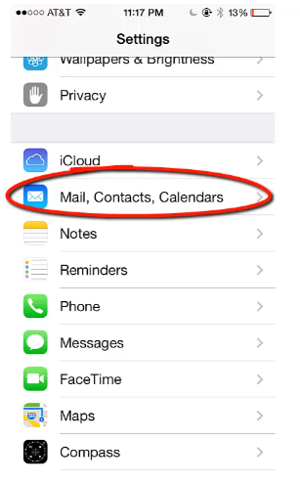

1. Go to the **SETTINGS**

Area on your phone

2. Choose **MAIL**

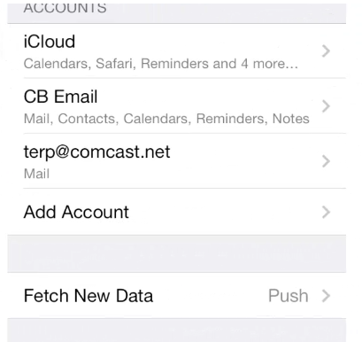

3. Choose   
**ADD ACCOUNT**

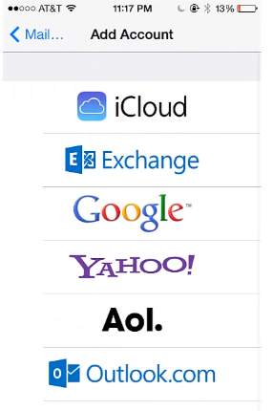

**4.** Choose the **EXCHANGE**

Account option



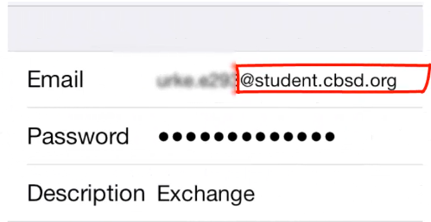

fox.b123@student.cbsd.org

**5.** Enter your **CBSD**

**Username** & **password**

(Be careful to enter it

in this format).

**lastname.f123@student.cbsd.org**

6. Choose **NEXT** and then choose **SAVE**